HTET LIN AUNG

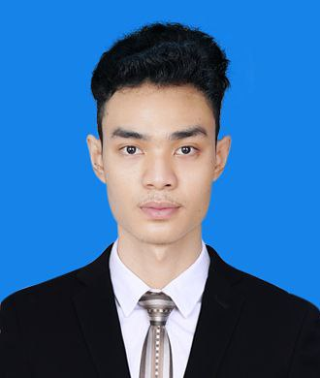
Looking forward for Automotive Service Technician with reputed organization that gives me an opportunity where I can improve my abilities and which provides an environment to share my skills with other so that I will be part of success in the organic.

- Report work order to workshop supervisor and communicate with service advisors and parts department.
- Perform diagnostic tests to identify problems engine, transmission and other components.
- Diagnose and repair electrical system using test equipment such as Pathfinder, SDD, Pico scopes and Multimeters.
- Engine troubleshooting and if need carry out engine overhauling with special tools and TOPIX instruction.
- Check coolant leakage, engine oil leakage, transmission fluid leakage ,cool climate fluid leakage and repair.
- Inspect air condition system, gas leakage, compressor damage, blower motor, and other electrical faults in HVAC module.
- Examine underneath noise, modified hydra bush from lower arm, air suspension system diagnosing.
- Explain the condition of vehicle, repair procedures, necessary repair parts and time needed to service advisor.
- Carry out the warranty processes, such as job card writing, time punching, follow TOPIX instruction and FSA if needed.
- Test steering system diagnosing, repairing, wheel alignment, wheel balancing.
Check accidental vehicle and repair the damage parts.

Career Objectives
DOB : 09 March 1996
Marital Status : Single
Passport No : MG 771928
Nationality : Myanmar
Availability : Immediate
Expected Salary : SGD 2500 (Nego;)
Automotive Service Techenician (Dec 2019– Present)
Capital Automotive Co,Ltd Yangon, Myanmar
Duties and Responsibilities:

AUTOMOTIVE SERVICE TECHNICIAN

Education Background
- Diagnosis, repair, and maintenance.
- Customer service.
- Analytical skills.
- General automotive technical knowledge.
- Electric and hybrid vehicle knowledge.

mghtet976@gmail.com

+959260512654 (WhatsApp)
Yangon, Myanmar.
Technical Skills
Bachelor of Engineering, Mechanical
Power (2012 – 2018)
Technological University (HINTHADA),
Yangon, Myanmar
Personal Information
Working Experience
Duties and Responsibilities,
- Learned safety practices, facility’s layout, using tools, wrenches and clean working environment.
- Performed maintenance services such as engine oil, brake fluid, air filter and etc.
- Accomplished Pre delivery inspection (PDI)
- Checked the brake pads and suspension system and if need performed the replacing new parts in order.
- Attended the morning meeting (daily) and learned the automotive knowledge shared by senior technician.

Summary
I have over 4 year experiences in service and maintenance skills that can contribute to the company’s growth as well as enhance my knowledge by exploring new things.

I hereby declare that above information is true and correct.

With Best Regard,
Htet Lin Aung
mghtet976@gmail.com
+959260512654(WhatsApp)

Language
Other Certificates
- Burmese : Native
- English : Advanced
- Certificate Of Qualification
( Bronze Technician ) from SUZUKI
- Proficient In Driving
(Auto, Mutual)
- Microsoft Office
- Able to work under pressure.
- Good at time management
- Strongly confident my skill
- Able to work in team, as well as independently.
- Fast learner and physically fit
- Methodical way of thinking
- Troubleshooting

Personal Skills
Automotive Service Technician Sep 2018 to Dec2019
Suzuki Garmanit Zay Ya Co, Ltd. Yangon, Myanmar
SUZUKI Dealer

Photo Reference

